

**Survival Guide**

**For**

**Parents & Athletes**

**Traveling to away events?...**

**Visit** [**www.bciaa.org**](http://www.bciaa.org) **and click on the member schools on the left side for very specific directions to athletic facilities.**

**Examples:**

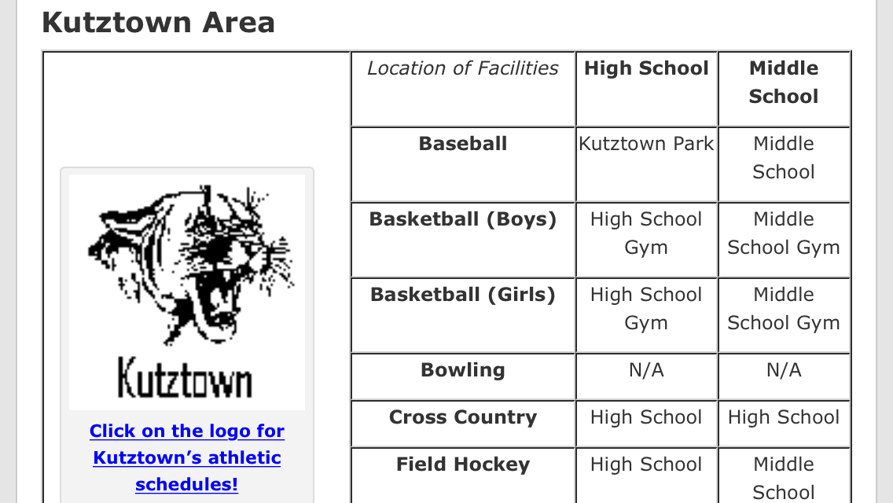

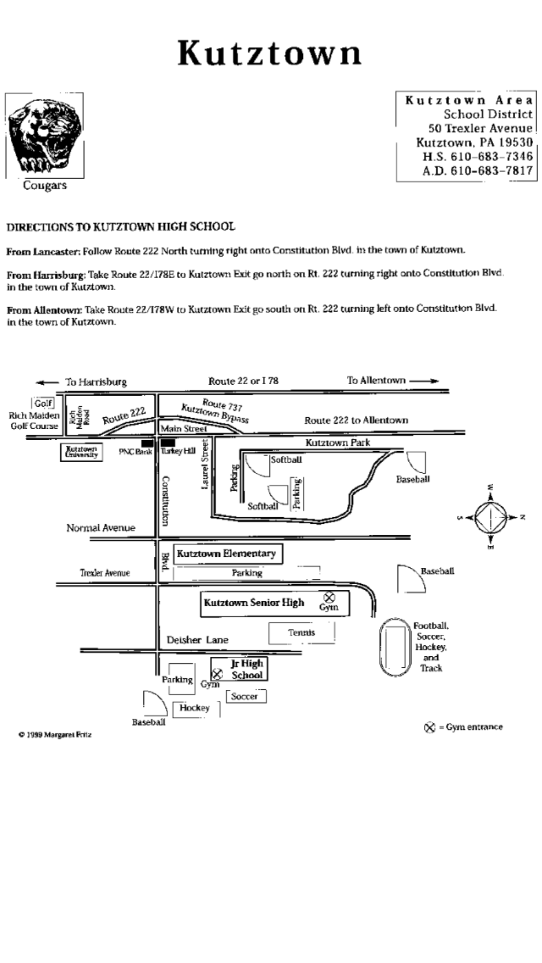

**Away events outside of Berks County:**

Visit <http://www.tulpehocken.org/athletics.aspx> and click on the Directions drop down box at the bottom right hand side of the page

**Don’t see a school you are looking for or no internet access?**

Call the Athletic Office at:

610-488-6286 x1160 or x1105





* Athletes should pack a snack or light dinner for all away events. Concessions may also be available, bring money to purchase.
* For longer or full day trips, lunch or dinner may be provided. Please check with your coach for more information.
* Athletes should pack a change of dry clothes in the event of inclement weather. Please check the temperature, as warm clothes and jackets may also be needed.
* Athletes should hydrate often during practice and game days. Water is the best supplement for hydration.
* Admission may be charged at away events for spectators

**Schedules**

* Scheduling Site - <http://tulpyathletics.com/main/calendar>
* Sign-up for email alerts and receive notifications when changes occur - <http://tulpyathletics.com/auth/login>
* Visit individual team sites for current season schedules



**Media Outlets**

* Important information is often posted on the following:
  + Twitter – ([www.twitter.com](http://www.twitter.com))
    - @TulpySports
    - @tulpyjshs
    - @tulpytrack1
    - @TulpySportsMed
  + Website – [www.tulpehocken.org](http://www.tulpehocken.org)
  + Team App
    - Tulpehocken Girls Tennis
    - Tulpy XC
    - Field Hockey – <https://tulpyfh.teamapp.com>
    - Tulpehocken Girls Basketball
    - Tulpehocken Softball
  + Facebook Pages
    - Field Hockey <https://www.facebook.com/TulpehockenFieldHockey/>
    - Cross Country
  + Instagram
    - @tulpyjshs

